Image processing Project

Omar Ahmed 222481 Fares Wael 224897 Amr Akl 222869

Smoothing Filters:

Median Smoothing Filter:

This function takes an image and make the image more smoother using the median filter, by selecting the kernel size you want. Minimum kernel is 3.

Image before:



Image after using kernel size 3:



Function:

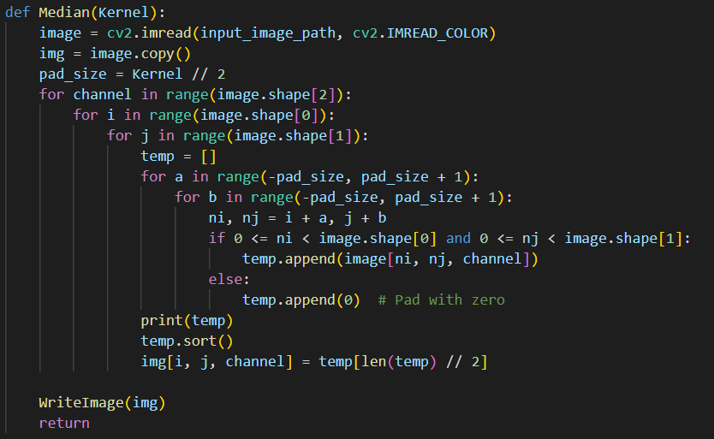

Adaptive median filtering:

This filter is an enhanced version of the median filter and makes the image smoother, and the kernel size can be customized.

Image before:



Image after using kernel size 3:



Function:

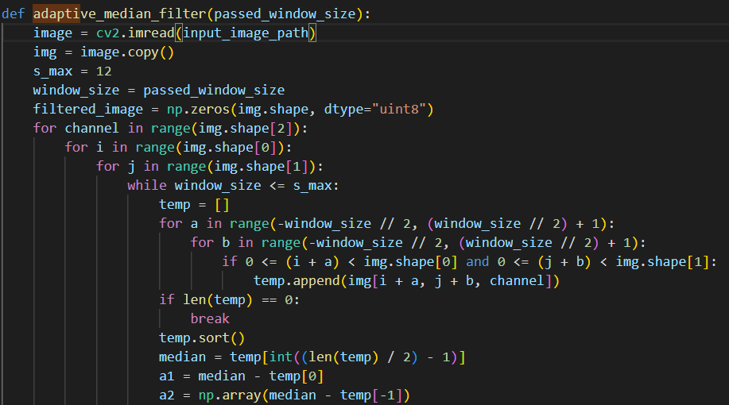

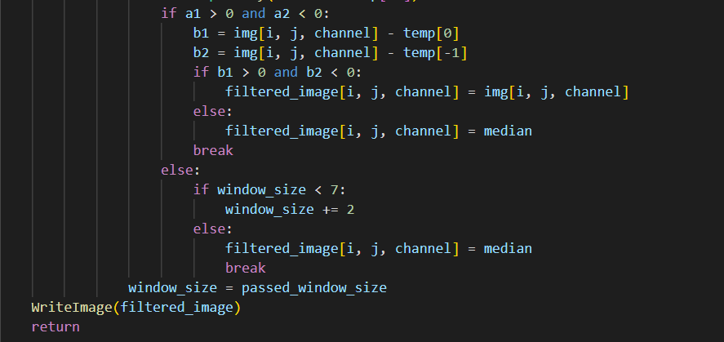

Averaging Smoothing filter:

This filter smoothers the image by computing the average by passing the kernel size.

Image before:



Image after using kernel size 3:



Function:

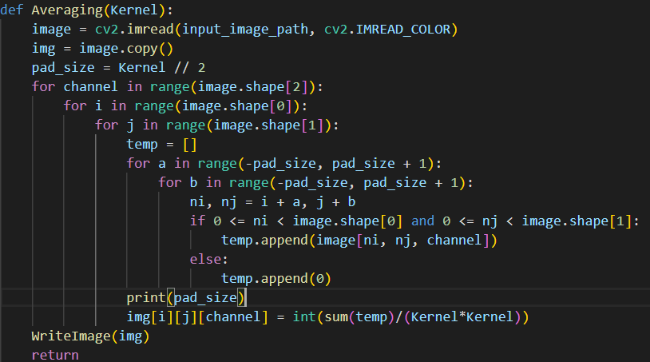

Gaussian smoothing filter:

This filter smoothers the image by passing the kernel size, and the sigma to customize the smoothing you want.

Image before:



Image after using kernel 5 and sigma 2:



Function:

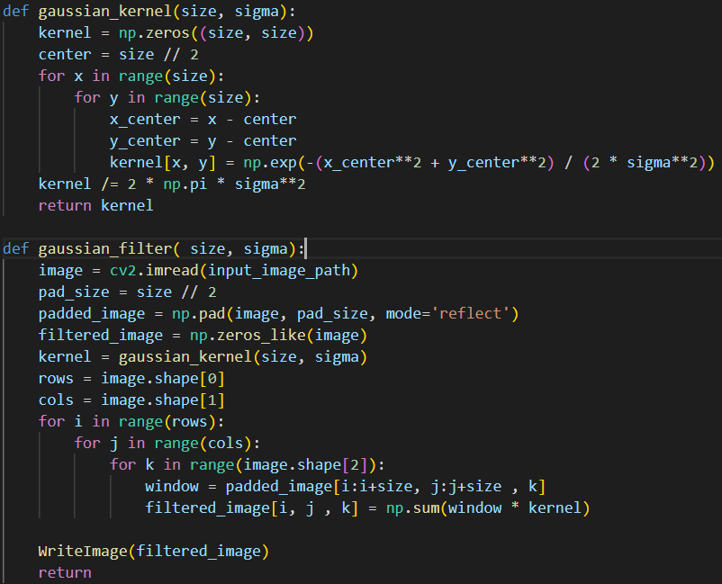

Sharpening filters:

La Placian Operator:

This sharpening technique extracts the edge mask of the image, and it has two modes, either show only the mask, or add the mask to the image and output the new image.

Original image:



Image after applying the first mode extract the mask:



Image after applying the second mode extract the mask then add it to the original image:



Unsharp Masking And Highboost Filtering:

Those filters use the same technique to sharpen the image, but with slight difference the weighted portion passed which is k determines which filter you’re using, if the k = 1 then it’s unsharp masking otherwise any value greater than 1 will be highboost which sharpens the image more.

Image before:



Image after using k = 1 (Unsharp Masking):



Image after using k = 5(Highboost filtering):



Roberts Cross-Gradient:

This filter extracts the edges of the image and it has two modes, wither show the mask or get the mask and add it to the original image.

Image before:



Image after extracting mask only:

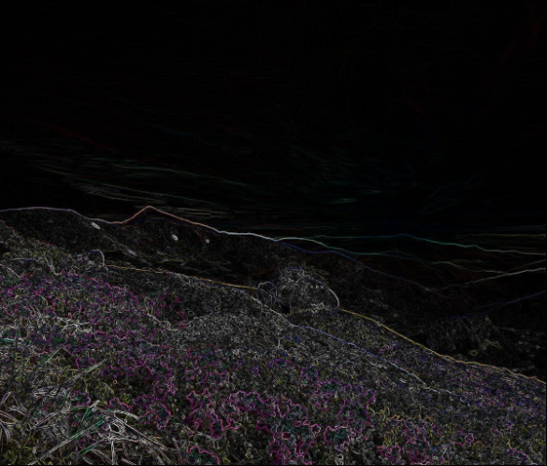

Image after adding mask to image:



Function:

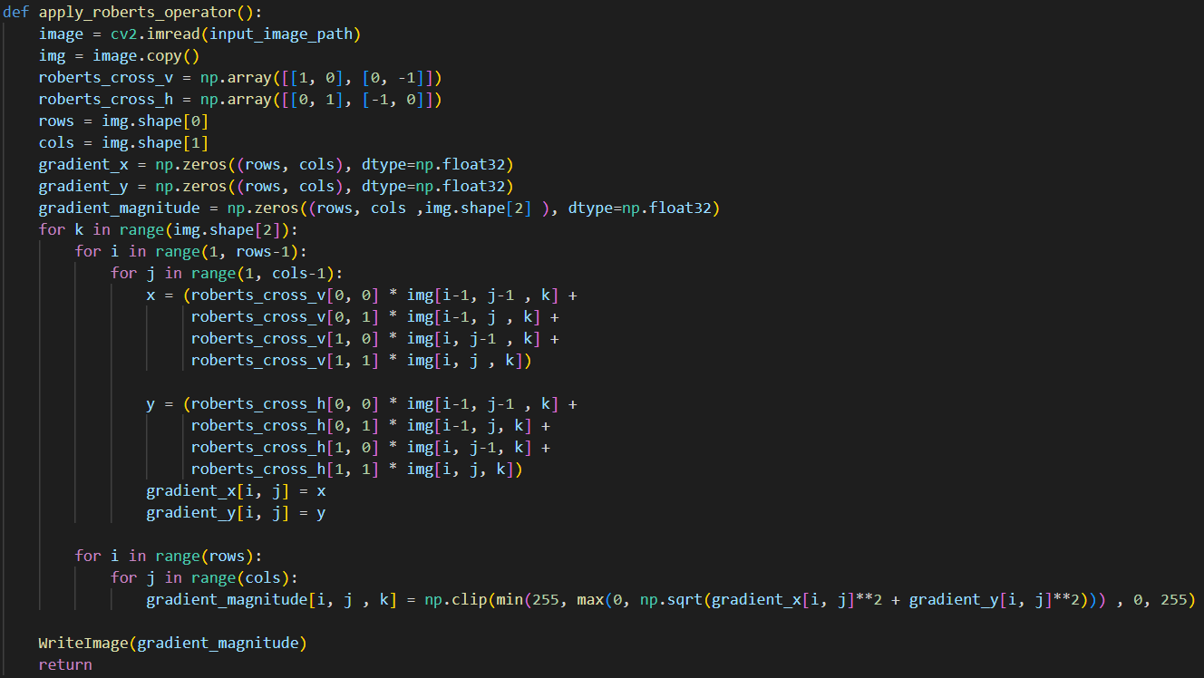

Sobel Operator:

Like the previous sharpening techniques it has two modes one for extracting the Sobel edges and the other add the extracted Sobel to the original image before:



Image after extracting the Sobel operator:

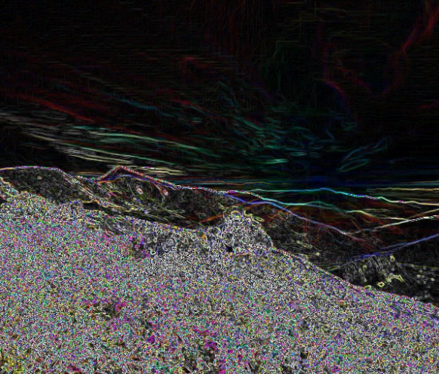

Image after adding the Sobel to the image:



Function:

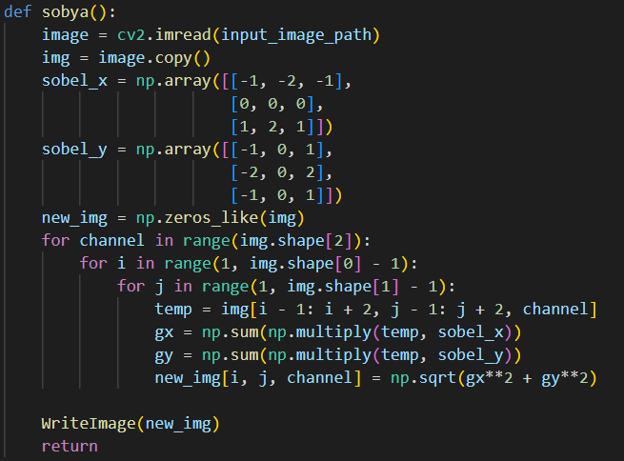

Noise Filters:

Salt and Pepper Filter:

This Filter corrupts the image using salt and pepper intensities.

Image before:



Image after applying the noise 0.05 salt 0.05 pepper:



Function:

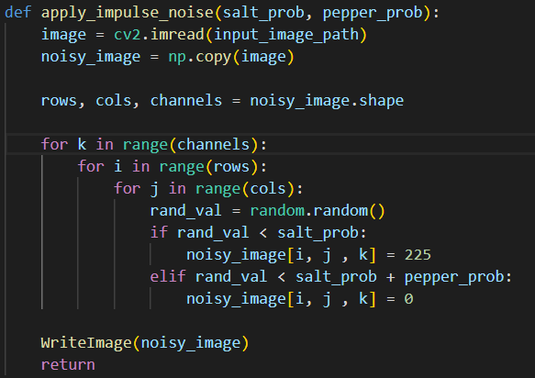

Gaussian noise:

This noise filter takes mean and standard deviation as input to customize the intensity of the noise.

Image before:



Image after applying noise using 0 mean and 20 standard deviation:



Function:

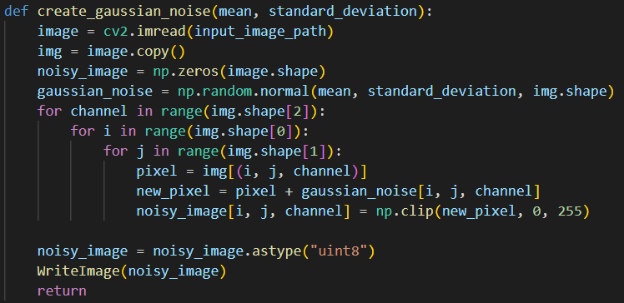

Uniform Noise:

This filter generates noise with different levels the higher the level the more corrupted the image will be.

Image before:



Image after applying noise with level 50:



Function:

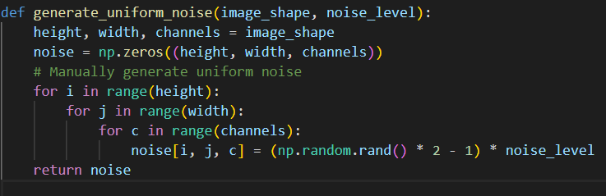

Frequency Domain:  
Histogram Equalization:

The histogram filter improves the contrast of the image be redistributing the intensity values of the image, so the resulting image is uniform.

Image before:



Image after:



Function:

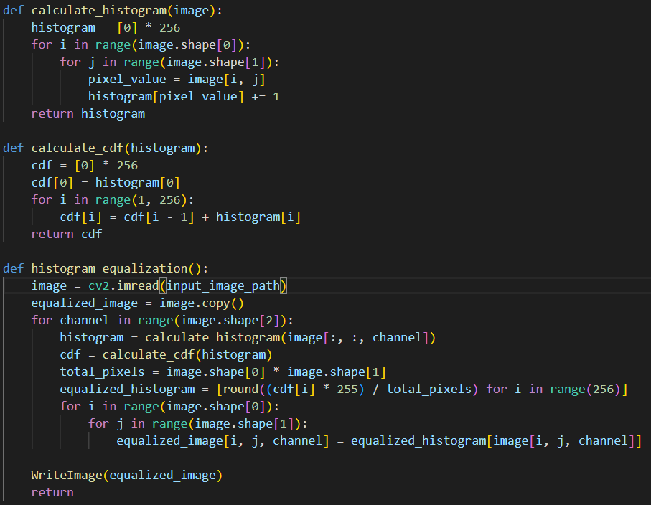

Histogram Specification

Image before:

The Histogram specification is adjusting the histogram of an image to match a specified image.



Image after:



Function:

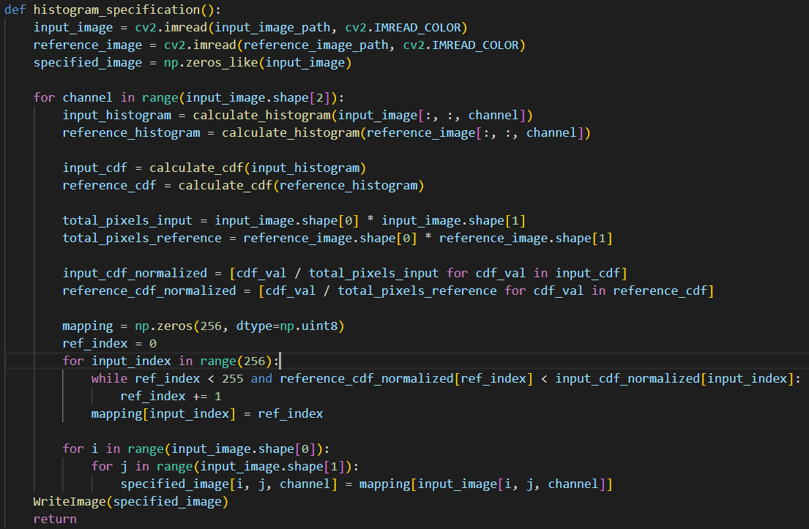

Nearest Neighbor Interpolation:

This filter receives the resize value and multiply it with the original image dimensions and every pixel is calculated by finding the nearest neighbor.

Image before:



Image after resize value 2:



Function:

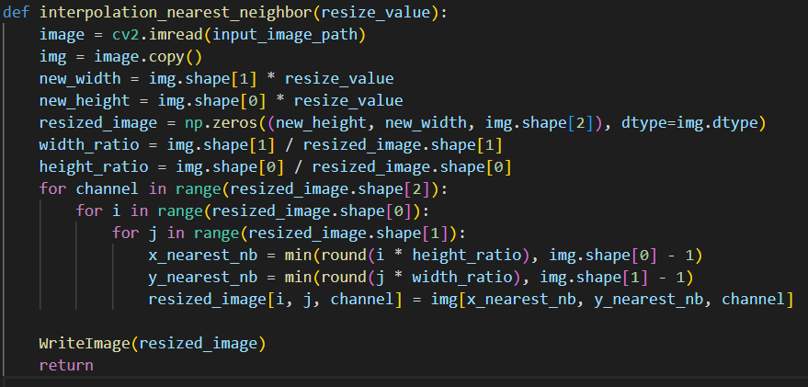

Bilinear Interpolation:

This filter receives the resize value to determine the new scale of the image, it calculates the new pixel value by calculating the weighted average for each pixel from the 4 nearest neighbors.

Image before:



Image after using resizing value of 2:



Function:

